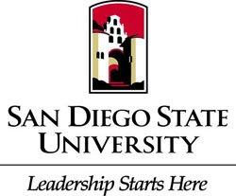
American Society of Civil Engineers
Student Chapter
General Body Meeting
Location: Park Boulevard
Date: September 20, 2016

- Call to Order
- What is Civil Engineering?
  - Definition & Significance
- Recap
  - 1st General Body Meeting
  - Back to School Picnic
  - Capture the Flag
  - Why we do this?
- PSWC Countdown Clock
  - ASCE SDSU will take first place this year!
- Upcoming Events
  - YMF General Body Meeting tonight 9/20 @ Stone Brewery
    - What is YMF?
  - Softball Tournament
    - We need volunteers!
    - Carpools Available
    - For questions contact any officer
- Announcements
  - National Concrete Canoe Competition Committee
    - For more questions contact, Valeria Ceron, asce.sdsu.president@gmail.com
b. AESC Representative Position
    - For more information contact, Jose Castro, asce.sdsu.treasurer@gmail.com
- APWA (American Public Works Association)
  - Jeneine Knight
- Guest Speaker
  - Paul Swearingen and Seana Urquhart (CalTrans)
- Membership
  - 25 dollar investment (one time)
    - Covers entire academic year
  - Must sign up with National member to participate in conference
  - Membership Form
    - Submit to Deborah Hug
      - Contact Information: 650-823-4829; hug.debs@gmail.com
- Ambassador Program
  - Brief Overview & Benefits
    - For more questions contact Andrea Farias
- Adjournment
  - Thank you

Check out our website: http://ascesdsu.weebly.com/
Join our facebook group: ASCE SDSU
Pay your dues on venmo: @ASCE-Treasurer

