American Society of Civil Engineers
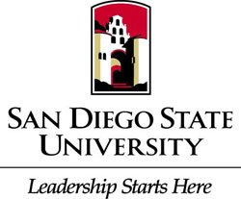
S.D.S.U Student Chapter
General Body Meeting
Location: Pride Suite Aztec Student Union
Date: March 1, 2016

- Call to Order
- Recap
  - Concrete Canoe Final Pour
  - E-Day @ the Mall
  - Scholarships & Internships
- Upcoming Events
  - Tours
  - PSWC Rooming & Driving List
  - Support Steel Bridge Fundraiser @Chipotle March 3rd 5-9 p.m.
  - YMF Interview/Resume Workshop March 16th @6 p.m.
  - De Anza Cove Pre Conference Picnic March 19th @ 10 a.m.
- Civil Engineering News
  - Ambassador Program
  - SEAOSD
  - APWA
- Guest Speaker
  - Jennifer Duffy with HDR
- Ethics
  - Initiative

