American Society of Civil Engineers
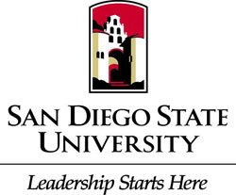
S.D.S.U Student Chapter
General Body Meeting
Location: Pride Suite Aztec Student Union
Date: March 15, 2016

- Call to Order
- Recap
  - Scholarships & Internships
  - Steel Bridge Fundraiser
  - Go Fund Me
- Upcoming Events
  - PSWC Driving List/ Facebook page
  - Community Service for PSWC March 22nd & 26th
  - YMF Interview/Resume Workshop March 16th @6 p.m.
  - De Anza Cove Pre Conference Picnic March 19th @ 10 a.m.
  - Explore SDSU March 19th
- Civil Engineering News
  - Senior Stoles
  - 18 amazing Facts about CIV E
- Guest Speaker
  - Dr. Supernak
- Ethics
  - Winners Never Quit and Quitters Never Win

