American Society of Civil Engineers
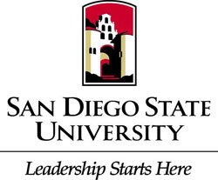
Student Chapter
General Body Meeting
Location: Pride Suite Aztec Student Union
Date: October 27, 2015

- Call to Order
- Recap
  - Concrete Canoe Pour Day
  - GeoWall Rubio’s Fundraiser
  - ASCE Encuentros Outreach
- Civil Engineering News
  - London Cross rail Expansion
- Upcoming Events
  - SDSU Career Fair
  - Adopt a Platoon
    - Donate to support our Troops
      - Deadline November 5th
  - Perished Troops Grave Cleaning
    - Saturday November 7th from 9 a.m.-12 p.m.
      - Fort Rosecrans National Cemetery
      - Please Volunteer to Honor the fallen
  - Professional Development Day November 12th
- Pacific Southwest Conference @CSULB
  - Teams
- New Position Available
  - Secretary
  - Contact Chris Cappel chris.cappel@gmail.com
- SEAOSD
  - Chad Closs
- Guest Speaker
  - City Engineer and Deputy Chief City Engineer
- Civil Engineering Ethics
  - Judgement
    - “The mark of an educated mind is the ability to entertain an idea without accepting or rejecting it”
- Adjournment
  - Thank you

