American Society of Civil Engineers
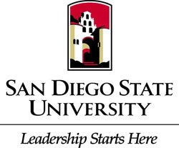
Student Chapter
General Body Meeting
Location: Pride Suite Aztec Student Union
Date: October 13, 2015

- Call to Order
- Recap
  - Steel Bridge Fundraiser at Woodstock’s
  - SDSU Tailgate
- Amendment to Bylaws
  - Late Fee and Why
- Civil Engineering News

- Upcoming Events
  - Geowall Rubio’s Fundraiser Oct 22nd
  - Adopt a Platoon
    - Donate to support our Troops
  - Professional Development Day Nov 12th
    - Send your resumes to president email
- Guest Speaker
  - Josh Stone (Michael Baker International)
- Civil Engineering Ethics
  - Failing Forward
- Thank you

