American Society of Civil Engineers
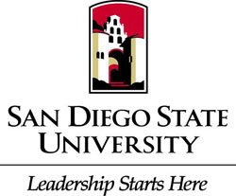
Student Chapter
General Body Meeting
Location: Pride Suite Aztec Student Union
Date: September 29, 2015

- Call to Order
- Recap
  - ASCE Golf Tournament
  - Softball Tournament
- Membership
  - Today is the deadline
    - Submit to Daniel Warstadt
    - Contact Information: 858-382-9058; dbwarstadt@gmail.com
  - Benefits
    - Exclusive information workshops events conference banquet
- Civil Engineering News
  - Xpress West
  - California Recycled Water Project
- Upcoming Events
  - Steel Bridge Fundraiser at Woodstock’s
    - Wednesday @6-10 p.m.
  - ASCE SDSU Tailgate October 3rd @4:30
  - YMF Sights & Sips Sunset Bay Cruise
- Guest Speaker
  - Carlos Mendoza
    - Water Resources
- CIV E Ethics
  - Responsibility to society
  - Define Your Why
- Adjournment
  - Thank you

