American Society of Civil Engineers
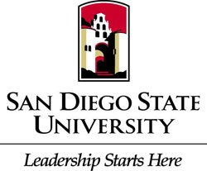
Student Chapter
General Body Meeting
Location: Pride Suite Aztec Student Union
Date: February 16, 2016

- Call to Order
- Recap
  - GeoWall is @ Nationals
  - Study with a Buddy
  - Scholarships
    - Visit our website for applications!
- Upcoming Events
  - YMF General Body Meeting February 16th
  - Concrete Canoe Final Pour February 20th
  - UCSD Tour February 23rd
  - Engineering Day @ the Mall (Chula Vista Center) February 27th
- Civil Engineering News
  - YMF
  - APWA
- Guest Speaker
  - Patrick Larkin, AECOM
- Ethics
  - Pursuit of Excellence

